Template for Evidence(s)
UI GreenMetric Questionnaire

University : ...
Country : ...
Web Address : …

[3] Waste (WS)
SAMPLE

[3.8] Organic Waste Treatment (WS.3)

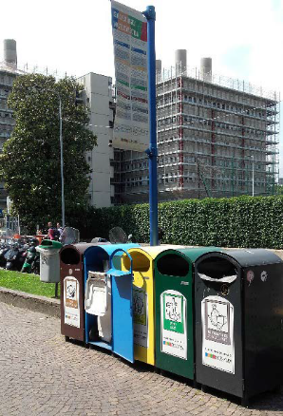
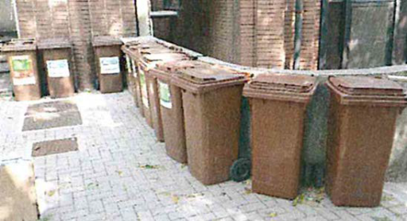
Example of Organic Waste Treatment (Politecnico di Milano, Italy)

Description:
(Please describe the program to treat organic waste on your campus. The following is an example of the description. You can describe more related items if needed.)

In Politecnico of Milan, the only structures that produce organic waste are canteens and cafés, which manage in complete autonomy this kind of waste. The canteens and the cafés manage the organic waste trough contracts with Amsa (Milan Environmental Services Company). Amsa collects the organic waste and it delivers them at an authorized waste treatment plant that processes the material through anaerobic digestion. The outputs of this system are: biogas, from which biomethane, electricity and liquid carbon dioxide for industrial use are produced, and organic fertilizers (http://www.amsa.it/gruppo/cms/amsa/; http://www.montello-spa.it/riciclo_rifiuti_organici/).

Additional evidence link (i.e., for videos, more images, or other files that are not included in this file):

